Student name
Institutional Affiliations
Instructor name
Course
Date

Photography has been one of the recent ways of conveying messages. Photography is not all about simply capturing a snapshot of objective reality. Photography uses real-world images in order to convey the world or society as the photographer sees it. In this way, the photographer tells a story by preparing a scene for his camera. The following photos are therefore the artwork of famous photographers who have used their photographs to convey a message to the world.
Both the photographs captured by Samuel Fosso of Martin Luther and that of Eileen Cowin of Marriage of Arnolfini the show qualities of different aspects that are to be upheld by the society. In Samuel Fosso’s photograph, the emphasis that is drawn is that of democracy of human rights as a way of speaking is depicted by Martin. On his black and white background is to show the originality of the African colour which is black. On the other hand, Eileen's photograph is trying to show the various aspects of marriage needed in society. The photograph conveys how people who are engaged should dress and the relationship they have.

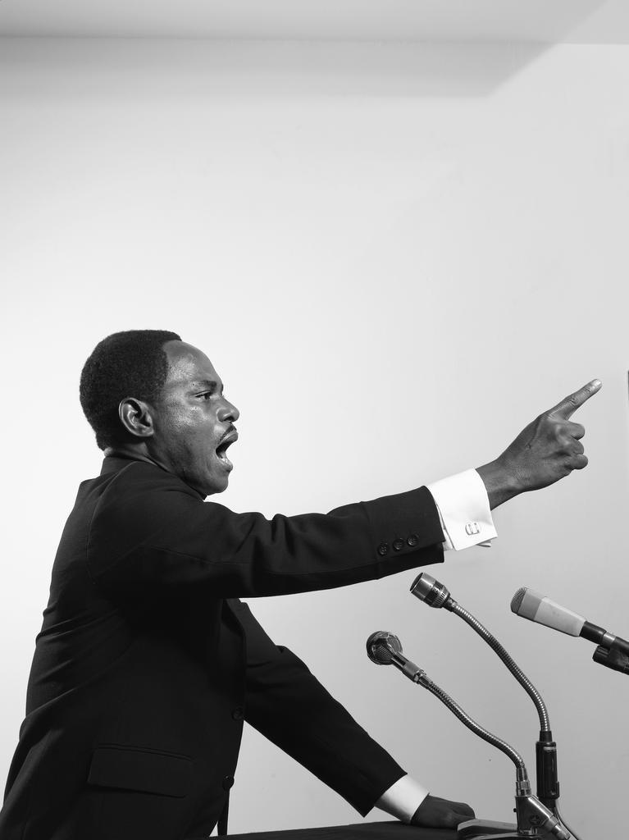
Martin Luther by Samuel Fosso
Samuel Fosso’s photograph is of one of the famous blacks who advocated for the rights of people in the Pan African liberation movement and the African American civil rights movement. He began his career taking wedding portraits and passport pictures. The photograph seems to have been taken from a close range. The camera only focussed on Martin and not the background hence ¾ of the photograph contains the figure of Martin and the remaining ¼ is the one covered by the background. It is black and white in order to show originality. On the front, there are three microphones on a stand. The photograph displays Martin giving a speech to a group of people in a conference because of the use of microphones. He seems to be persisting on some point towards the multitude by the show of his hand and the way his lips are moving. This can be seen from his facial expression. The gesture made by Martin shows that he is emphasizing on the issue of democracy. He is maintaining eye contact with the audience.
The image displays the original scene, the light and the clothes including the pose and the facial expressions are almost identical. The photograph was made in Gelatin silver print in the year 2008. The paper dimensions of the photograph are 40*29.92 inches. The framed dimensions that were made are 40.83*30.67*1.77 inches. The photograph has been on an exhibition of the Structure of Identity at the Fundacion Foto Colectania in Barcelona.
The photograph was made for various reasons. The photograph was taken during the iconic "I have a dream" speech in the year 1963 in Washington DC that had more than 250000 participants. This was one of the largest and the most memorialized human rights demonstrations in history. On every Monday of the month of January, the United States celebrates the life and legacy of Dr.Martin Luther King. Various books and films have also engaged with Luther's stirring and they have got a challenge to combat racism and oppression. The photograph was made to display the good qualities and legacies left by the late Luther. The photograph displays the true African leaders in action. It also reminds people on how Martin allowed them to be free, in a way, and hence the photograph gives him the place in history so that the future generation will remember what has happened in the past and what is still happening today.
The photograph was made by encircling with a rectangular plastic and covered a transparent glass that can be seen through. This frame protects the photograph from destruction or tearing by people who like touching pictures or having a close view. The photograph is maintained and conserved by ensuring regular cleaning of dust and photograph of the frame to make it look attractive. There are also, people who are hired to keep watch on the photograph so that it does not destroy. The photograph display is changed periodically because most photographs deteriorate in light over time. The air entering the exhibition area of the photograph is controlled by being filtered and purified. The handling and use police are established and the staff is trained on the policies and telling the users the policies when they arrive. The photograph is preserved in the museum so that the future generation can see what the past generation was going through.
On the photograph of Eileen Cowin who is an American and was born the year 1947 focusses on the depiction of personal relationships and the exploration of photography's narrative possibilities. The image is all about the American culture. The caption seems to be a bit far. About ½ covers the featured man and woman and the other half feature the background. The man is close to the woman and he the man has a hat on his head. The man has maintained eye contact while the woman is seen facing down. This is showing that a woman is not supposed to look at his husband directly. Her face shows that she is a young woman and the dressing mode indicates that she is from modern society. It was taken in a dark room. This brings out the specific art historical moments into the present. Another focus on this photograph is the red dress that the woman is wearing while the background is dark. This catches the viewer’s attention in order to see the decent dressing of women.
The dimensions of the photograph are 66*50.8 cm which is equivalent to 26*20 inches. It has the object number 2015.15.45. It displays the original scene; the clothes can be well seen including the skin colour of the two people. The technique of applying a layer after a layer of thin translucent glazes create a photograph with the intensity of both tone and the colour. The glowing colours help the photograph in highlighting the realism and show the material wealth. The photograph has been on the exhibition at Reenactment in Contemporary Photograph on March 12 to June 9 in the year 2019. It has also been exhibited at the J Paul Getty Museum at the Getty Centre in Los Angeles on March 12 to June 9 in the year 2019.
The photograph was made in order to display the American culture of marriage. The photograph contains a posed portrait of a man and a woman imitating the pose of Jan Van “Marriage of Arnolfini”. The man is wearing a dark suit and hat and the woman is wearing a red dress and a white head scarf. There is also a small black dog that is sitting at the woman ‘s feet. It shows the relationship that exists between a man and a woman. The image shows the man holding the woman’s hand while taking a vow. The small dog on the woman’s feet symbolizes fidelity, loyalty or it can be seen as an emblem of lust signifying the couples desire to have a child. The woman can be thought as to be pregnant but it isn’t. It is actually the dress that has been holding up in the contemporary of fashion.
Preservation generally improves the appearance of the photograph. The photograph is maintained through by ensuring proper environments such as control of the temperature and relative humidity. The is also kept cool for the original prints and transparencies. The photograph display is changed periodically because most photographs deteriorate in light over time. The air entering the exhibition area of the photograph is controlled by being filtered and purified. The handling and use police are established and the staff is trained on the policies and telling the users the policies when they arrive. The photograph is kept in a paper enclosure for its long-term stability. Reproductions for use in exhibitions and by the researchers is made and it reduces the damage caused by non-controlled environments and handling. The photograph is also digitized to allow access to a large multitude.
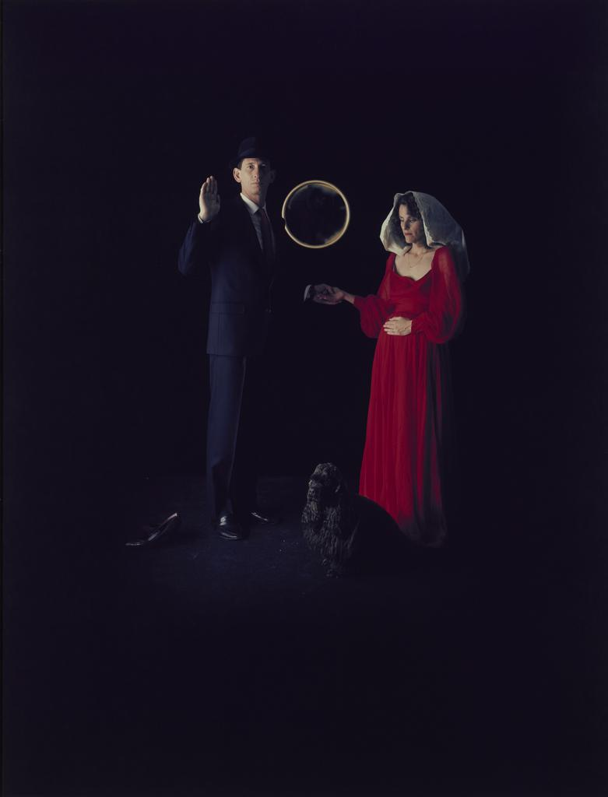
Marriage of Arnolfini by Eileen Cowin
Through the photographs of both artists background colour, the gesture expression and visual expression the aspects of marriage and self-expression on human rights have changed people’s views. Now women can be able to understand how they are supposed to present themselves during the marriage. Samuel Fosso's photograph is a great ideal for the recent generation because it shows how Martin Luther fought for human rights.

